Staffing Plan

PROJECT NAME

Confidential and Proprietary Information
This document contains information that is proprietary to <COMPANY NAME>. Transmittal, receipt, or possession of this document does not express license, or imply rights to use, sell, design, manufacture, or to have manufactured, any product, concept, or service from this information. No reproduction, publication, or disclosure of this information, in whole or in part, electronic or otherwise, shall be made without prior written authorization of an officer of <COMPANY NAME>
Authorized transfer of this document from the custody and control of <COMPANY NAME> constitutes a loan for limited purpose(s), and this document must be returned to <COMPANY NAME> upon request, and in all events, upon completion of the purpose(s) of the loan.
Document Change Log

Prepared By | Title | Date | Version

Revisions

Modified By | Reason | Date | Version

TABLE OF CONTENTS

1. Introduction 4
2. General Information 4
3. Skills Assessment 4
4. Staffing Profile 5
5. Organization Chart 6
6. Outside Resource Profile 6
7. Project Roles and Responsibilities 7

Introduction

General Information
[Enter the name of the project, the client, the project manager, and the project start and end dates.]

Project Name: _____________________________

Project Manager: ____ ______________________

Project Begin Date: _XX/XX/XXXX Project End Date: _XX/XX/XXXX

Skills Assessment
[Describe the types of personnel/project roles required to complete the project milestones, from planning through post-deployment. Include the timeline/duration, title, source, project role and skill level.]

Milestone/Objective | Title | Source | # | Skill Level /Special Requirements
Milestone # 1 | Project Manager | Internal
 | Technical Lead | Internal | 1
 | Business Analyst | Internal | 1
Milestone #2 | User Interface Designer | Internal
 | DBA | Internal | 1
 | QA Engineer | Internal | 2
 | Software Engineer | Internal | 4

Staffing Profile
[Define the people resources required for the project, including required hours per week and duration of tenure.]

Calendar  (month or quarter) | Title  (personnel category) | Resource Name | Level of Commitment  (utilization rate)
Period #1 | Project Manager |  | 1 – Full time
 | Technical Lead |  | 1 – Quarter time
Period #2 | Project Manager |  | 1 – Full time
 | Quality Assurance |  | 1 – Half time
 | Software Engineer |  | 4 – Full time
Period #3

Organization Chart
[The organization chart produced for the Project Definition Document should be updated to include individual names of project team members. If you have Microsoft Visio installed on your computer, the Visio diagram below can be opened and updated by right clicking on it and selecting Visio Object and Open. Or you can delete the organizational chart below and insert your own.]

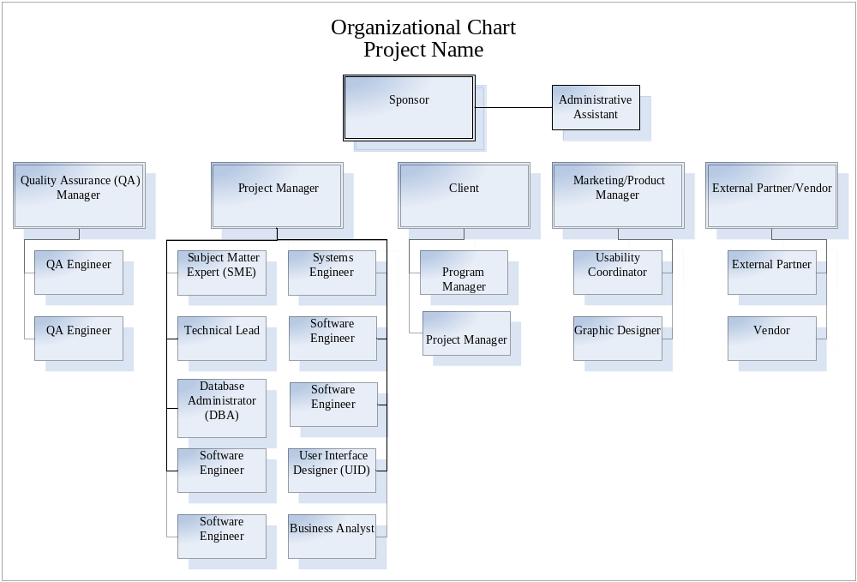

Outside Resource Profile
[This section is used to identify any outside resources assigned to your project. This will include client and vendor representatives; and consultants or contractors assigned to project.]

Calendar  (month or quarter) | Title  (personnel category) | Resource Name | Company | Level of Commitment  (utilization rate)
May-July | Project Manager |  |  | 1 – Full time
 | Technical Lead |  |  | 1 – Quarter time
August - October | Project Manager |  |  | 1 – Full time
 | Quality Assurance |  |  | 1 – Half time

Project Roles and Responsibilities
[This is where the roles and responsibilities for each team member, including client and vendor representatives, are described in detail. It is important that this section is clear, unambiguous, and understandable to everyone on the project team.]

Resource Name | Title | Project Role | Responsibilities
 | Project Manager | Manager and owner for development and delivery of product

